// DEEPIKA SHARMA -124959

LAB -2.2 Group Functions:

- Display the Highest, Lowest, Total & Average salary of all staff. Label the columns Maximum, Minimum, Total and Average respectively. Round the result to nearest whole number.
Ans. REFER TABLE: Staff_Master
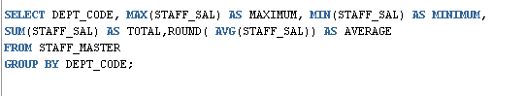
OUTPUT:
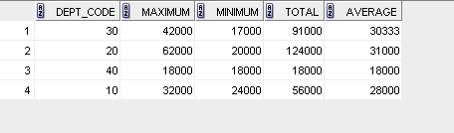
- Edit the above query and display the same for each Department Name.
Ans. REFER TABLE: Staff_Master,Department_Master
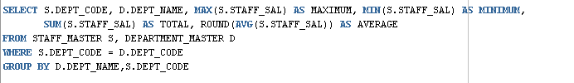
OUTPUT:
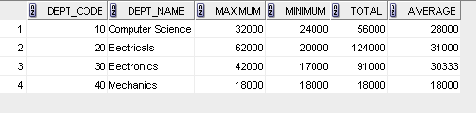
- Write a query to display number of people in each Department. Output should display Department Code, Department Name and Number of People.
Ans. REFER TABLE: Staff_Master,Department_Master
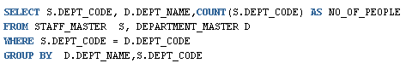
OUTPUT:
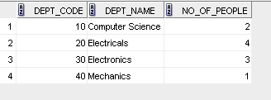
- Determine the number of managers without listing them. Label the column as ‘Total Number of Managers’.
Ans. REFER TABLE: EMP
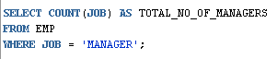
OUTPUT;
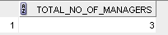
- Display Manager Code, Manager Name and salary of lowest paid staff in that manager’s team. Exclude any group where minimum salary is less than 10000. Order the result on descending order of salary.

